Contents

Task No. 1 (Create following table:) 2

Task No. 2 (Create a form for inserting Faculty details in Access Database.)…………………3

Task No. 3 Create suitable report of the given database that shows all the records)…………..4

Task # 01: Create following table:
Table Name: Faculty
Column 1: Faculty_Id (AutoNumber) PK
Column 2: Name (Short Text)
Column 3: Designation (Short Text)
Column 4: Contact No (Number)
Column 5: City (Lookup Wizard)
Column 5: Dept_Name (Lookup Wizard)
Column 6: Picture (Attachment)
Insert three records into this table and save the results.

Solution:
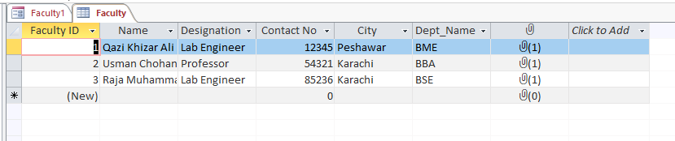

Task # 02: Create a form for inserting Faculty details in Access Database.
Table Name: Faculty.
Solution:

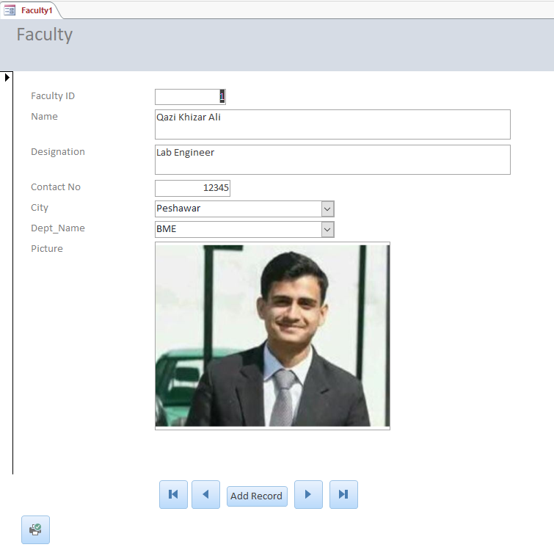

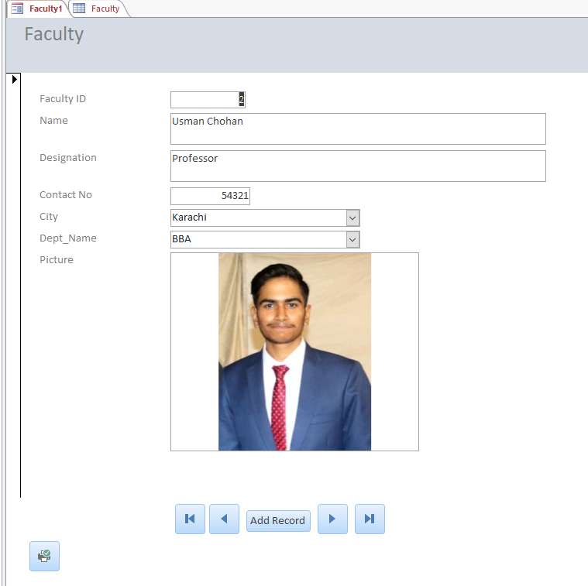

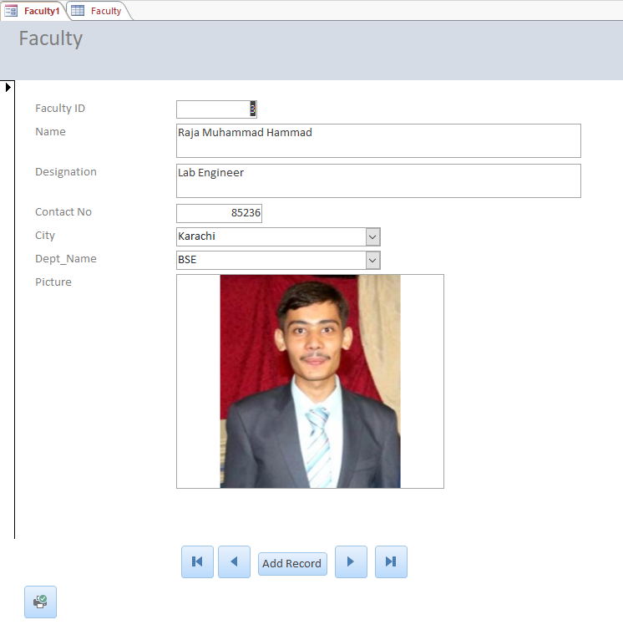

Task # 03: Create suitable report of the given database that shows all the records stored in the table.

